|  |
| --- |
| GATE |
| Linear Algebra |
| PYS’s and Solution |

|  |
| --- |
| VARUN KUMAR  7-31-2025 |

Table of Contents

**CSE** 3

2025 3

2024 4

2023 6

2022 7

2021, S-1 9

2021, S-2 10

2020 10

2019 10

2018 11

**ECE** 12

2025 12

2024 12

2023 13

2022 14

2021 15

2020 15

2019 16

2018 16

**EEE** 17

2025 17

2024 18

2023 19

2022 19

2021 20

2020 21

2019 21

2018 22

**Civil** 23

2025 23

2024 25

2023 26

2022 28

2021 29

2020 31

2019 32

2018 32

**Mechanical** 34

2025 34

2024 34

2022 35

2021 36

2020 36

2019 37

2018 38

**Instrumentation Engineering** 39

2025 39

2024 40

2023 41

2022 41

2021 42

2020 43

2019 43

2018 44

2017 44

2016 44

**Data Science and Artificial Intelligence** 45

2025 45

2024 47

**IIT JAM – Mathematics** 50

# **CSE**

## 2025

**S1**

**Q.** Consider the given system of linear equations for variables 𝑥 and 𝑦, where 𝑘 is a real-valued constant. Which of the following option(s) is/are CORRECT?

$$x + ky = 1$$

$$kx + y = -1$$

1. There is exactly one value of 𝑘 for which the above system of equations has no solution.
2. There exist an infinite number of values of 𝑘 for which the system of equations has no solution.
3. There exists exactly one value of 𝑘 for which the system of equations has exactly one solution.
4. There exists exactly one value of 𝑘 for which the system of equations has an infinite number of solutions.

ANS: - a, d

**Q.** Let 𝐴 be a 2 × 2 matrix as given.

$$A= \left(\begin{matrix}1 & 1 \\ 1 & -1\end{matrix}\right)$$

What are the eigenvalues of the matrix 𝐴13?

1. 1, −1
2. 2√2, −2√2
3. 4√2, −4√2
4. 64√2, −64√2

**ANS: - d**

**S2**

**Q**. If $A= \left(\begin{matrix}1 & 2 \\ 2 & -1\end{matrix}\right)$ then which ONE of the following is 𝐴8?

a. c.

b. d.

ANS: - c

**Q.** Let 𝐿, 𝑀, and 𝑁 be non-singular matrices of order 3 satisfying the equations

$$L^{2}= L^{-1}, M=L^{8}, and N= L^{2}$$

Which ONE of the following is the value of the determinant of (𝑀 − 𝑁)?

1. 0
2. 1
3. 2
4. 3

ANS: - a

**Q.** Consider a system of linear equations 𝑃𝑋 = 𝑄 where $P ∈ R^{3 X 3}$ and $Q ∈ R^{3 X 1}$. Suppose 𝑃 has an LU decomposition, 𝑃 = 𝐿𝑈, where

L = $\left[\begin{matrix}1 & 0 & 0 \\ l_{21} & 1 & 0 \\ l_{31} & l_{32} & 1\end{matrix}\right]$ and $U=\left[\begin{matrix}u_{11} & u_{12} & u_{13} \\ 0 & u_{22} & u_{23} \\ 0 & 0 & u_{33}\end{matrix}\right]$

Which of the following statement(s) is/are TRUE?

1. The system 𝑃𝑋 = 𝑄 can be solved by first solving 𝐿𝑌 = 𝑄 and then 𝑈𝑋 = 𝑌.
2. If 𝑃 is invertible, then both 𝐿 and 𝑈 are invertible
3. If 𝑃 is singular, then at least one of the diagonal elements of 𝑈 is zero.
4. If 𝑃 is symmetric, then both 𝐿 and 𝑈 are symmetric.

ANS: - a, b, c

## 2024

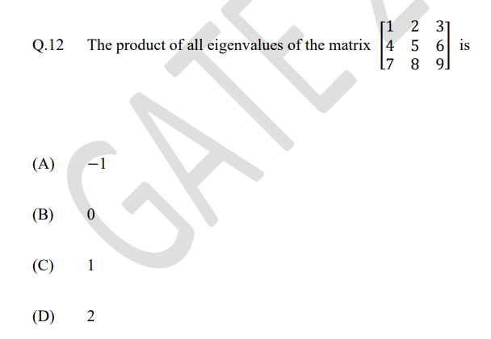

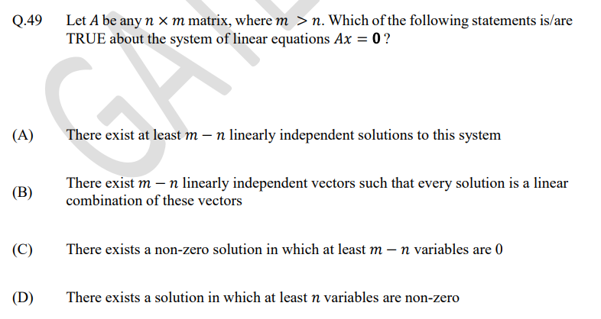

**S2**

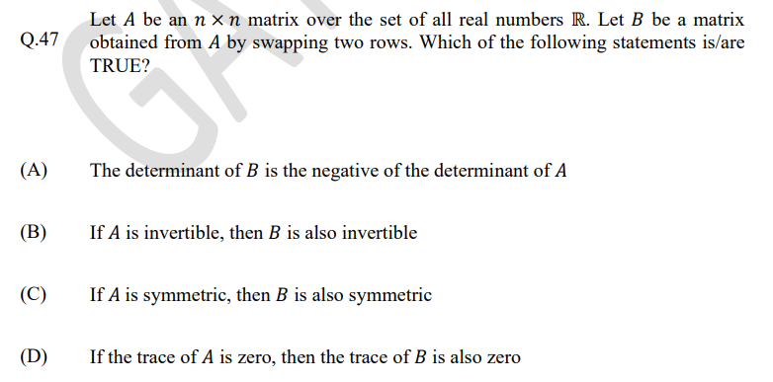

## 2023

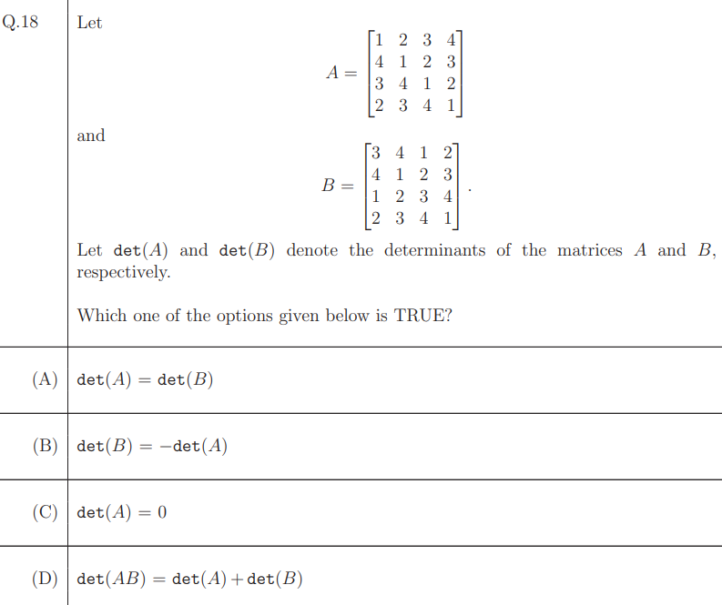

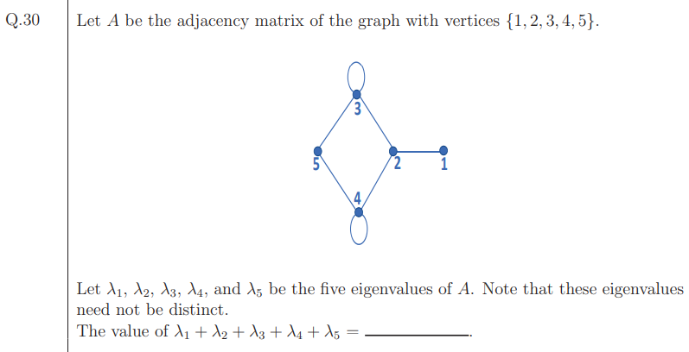

## 2022

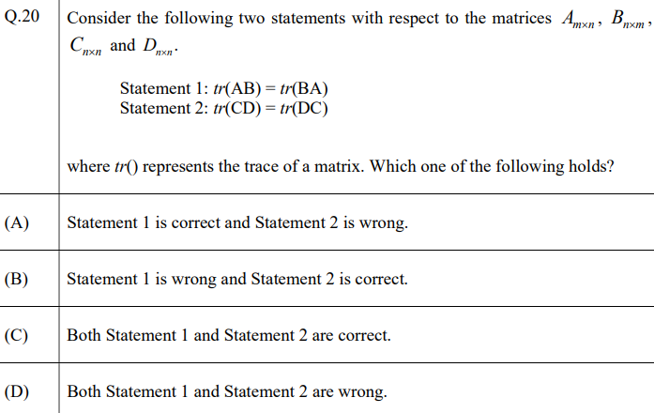

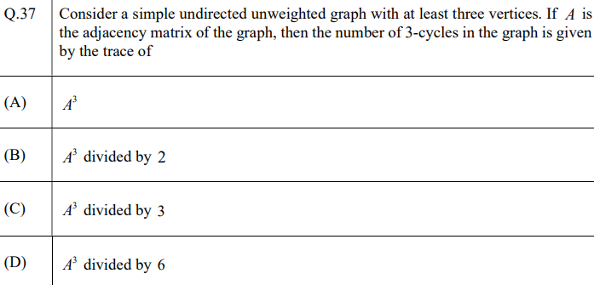

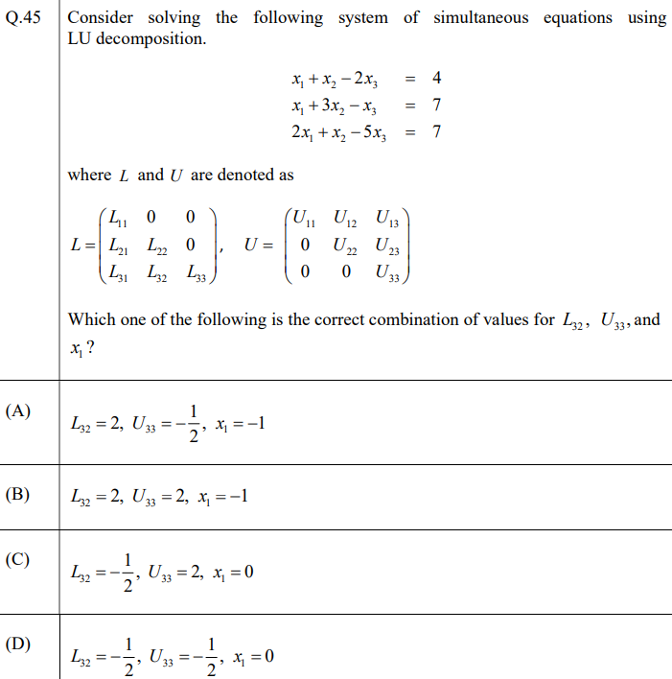

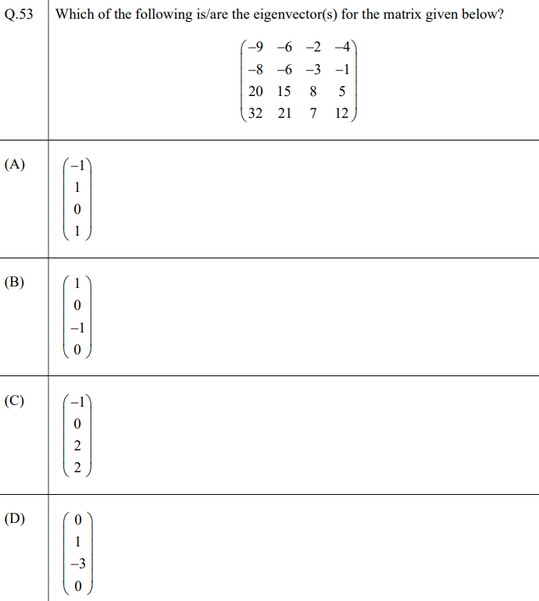

## 2021, S-1

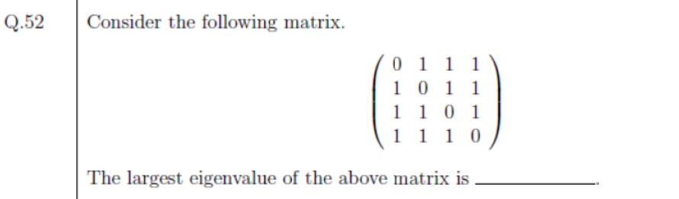

ANS: - 3

## 2021, S-2

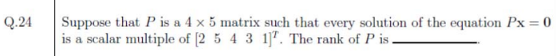

ANS: - 4

## 2020

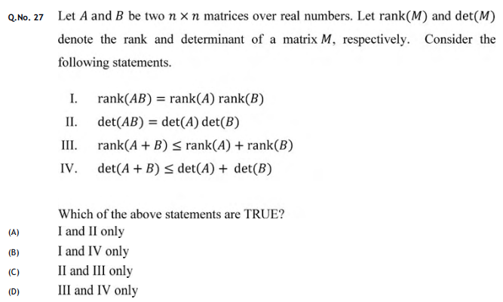

ANS: - C

## 2019

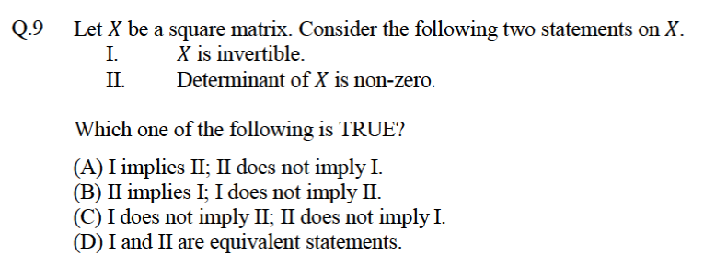

ANS: - D

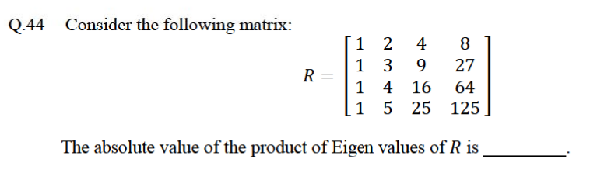

ANS: - 12

## 2018

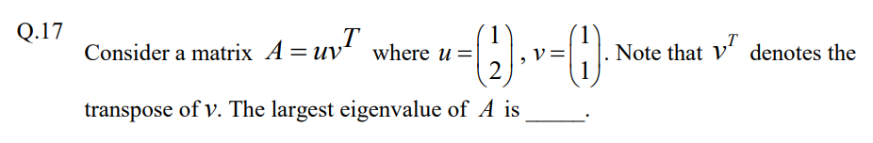

ANS: - 3

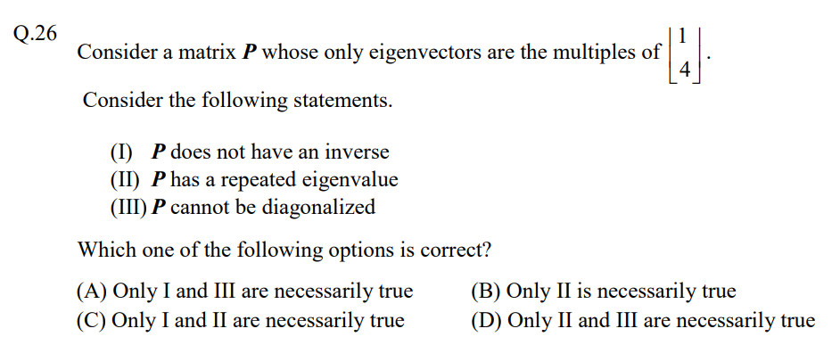

ANS: - D

# **ECE**

## 2025

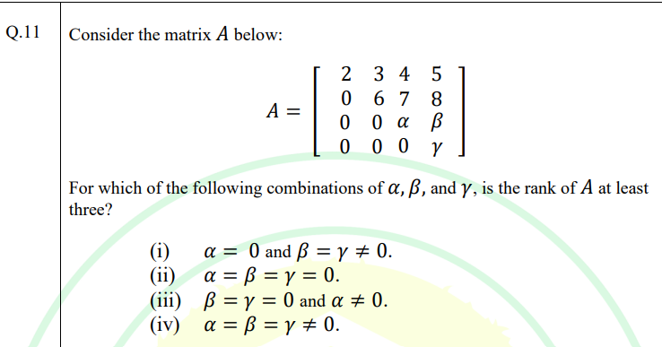

(A) Only (i), (iii), and (iv)

(B) Only (iv)

(C) Only (ii)

(D) Only (i) and (iii)

ANS: - A

## 2024

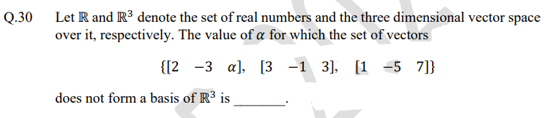

ANS: - 5 (Check the answer)

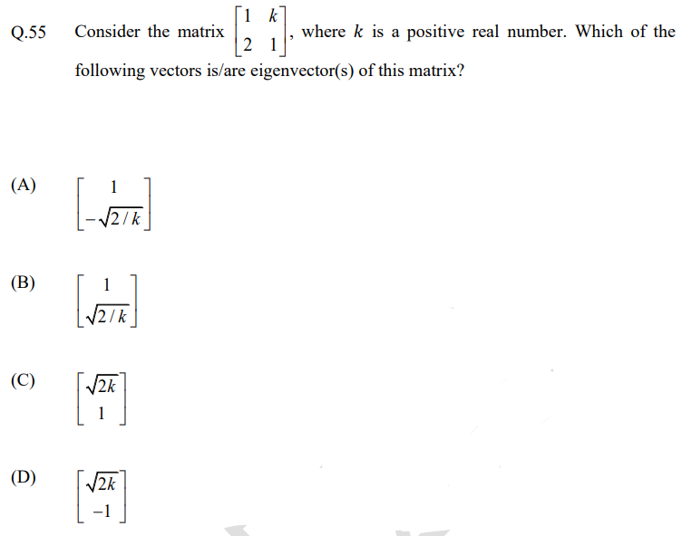

ANS: - A, B (check the answer)

## 2023

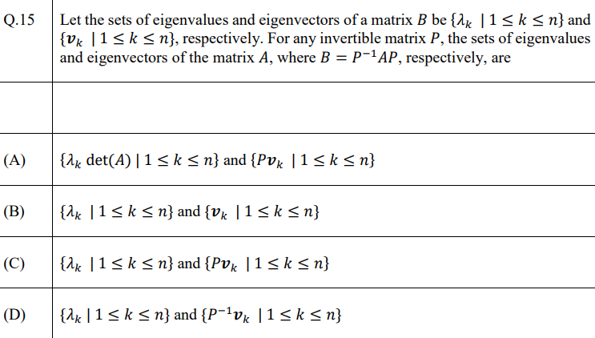

ANS: -

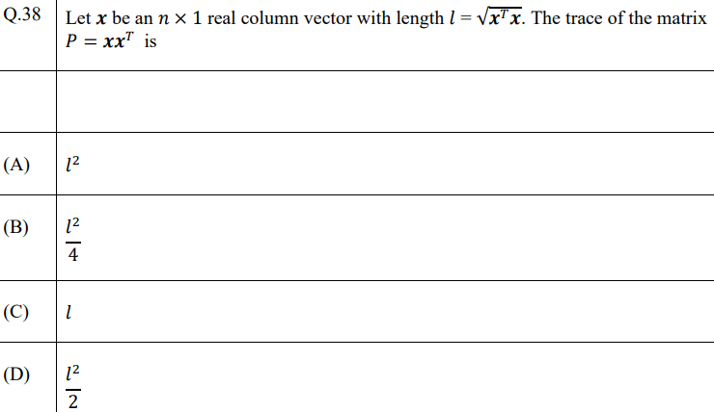

ANS: -

## 2022

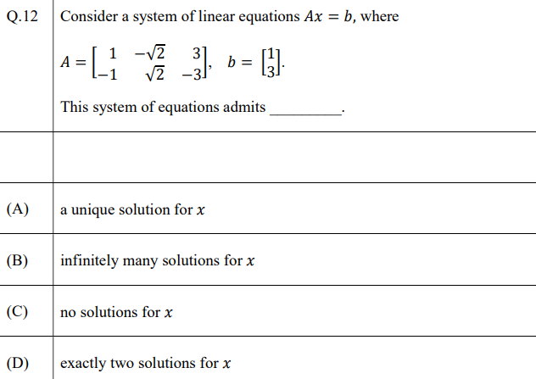

ANS: -

## 2021



ANS: -

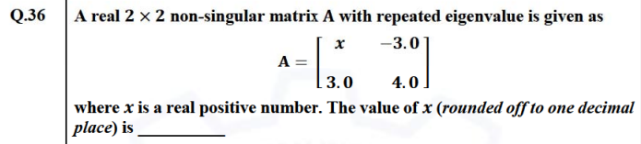

ANS: -

## 2020

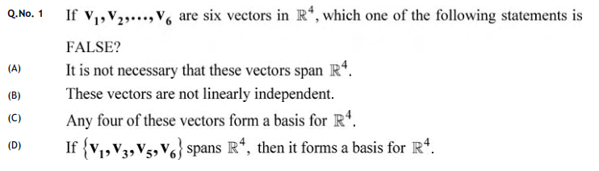

ANS: - C

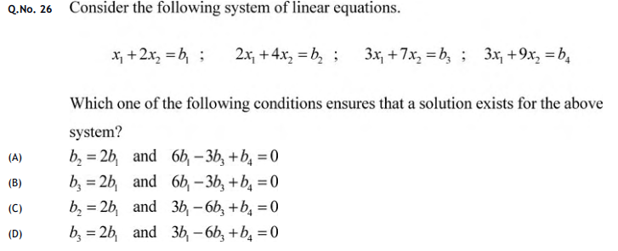

ANS: - A

## 2019

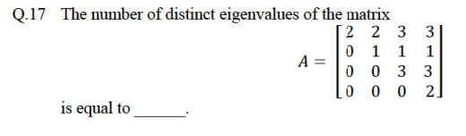

ANS: - 3

## 2018

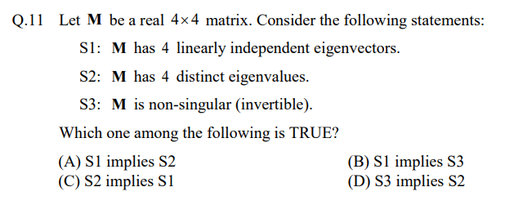

ANS: - C

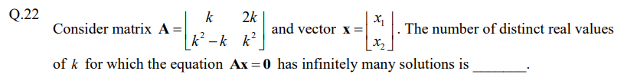

ANS: - 2

# **EEE**

## 2025

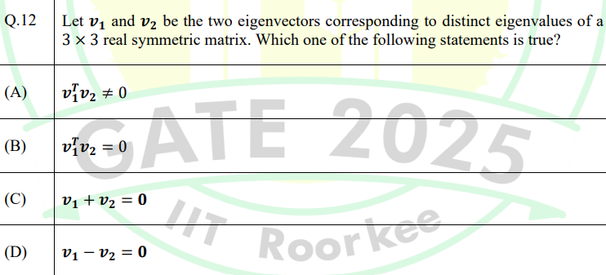

ANS: - B

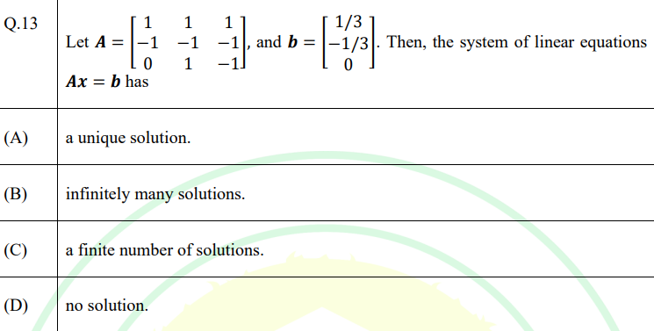

ANS: - B

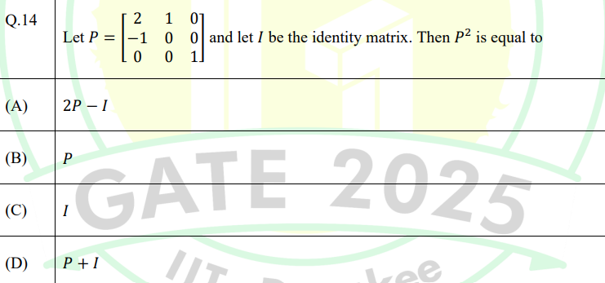

ANS: - A

## 2024

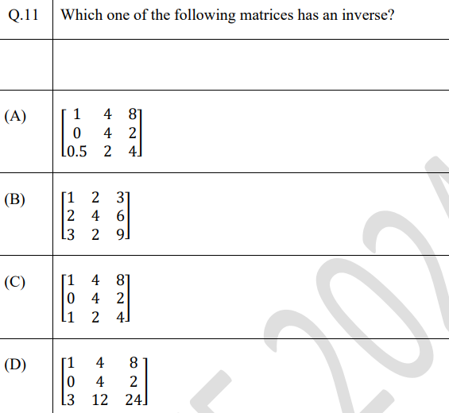

ANS: -

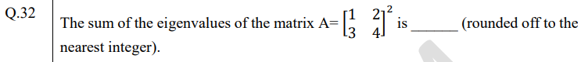

ANS: -

## 2023

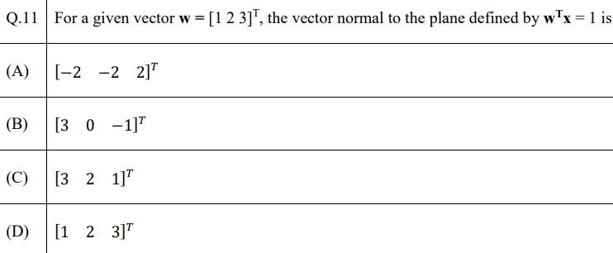

ANS: -

## 2022

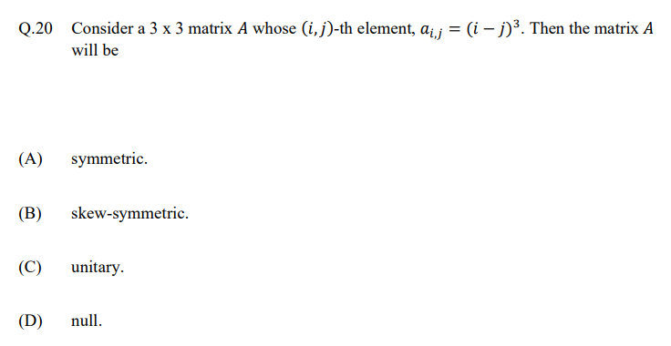

ANS: -

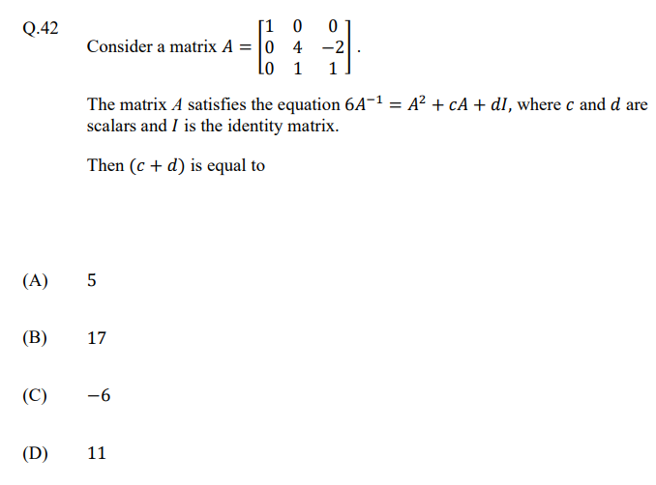

ANS: -

## 2021

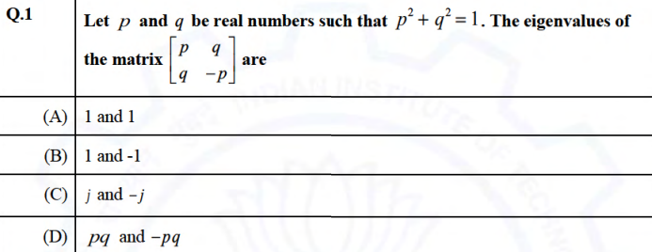

ANS: - B

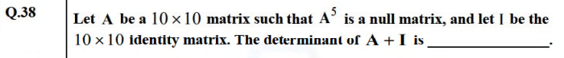

ANS: - 1

## 2020

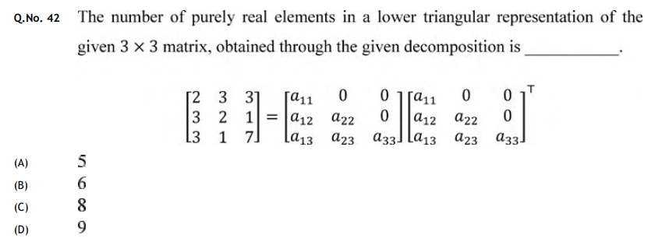

ANS: - MTA

## 2019

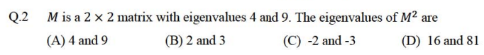

ANS: - D

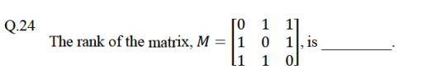

ANS: - 3

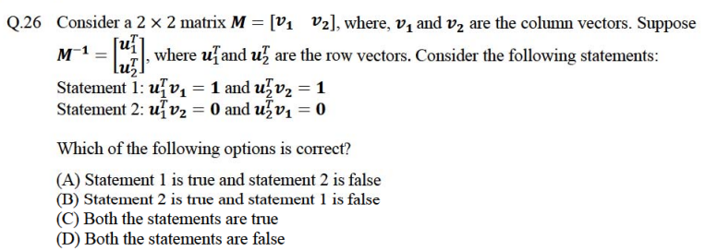

ANS: - C

## 2018

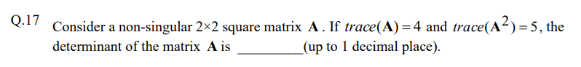

ANS: - 5.5

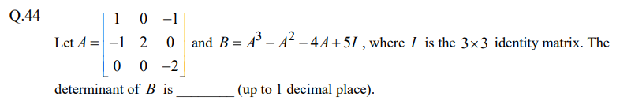

ANS: - 0.9 - 1.1

# **Civil**

## 2025

CE 1

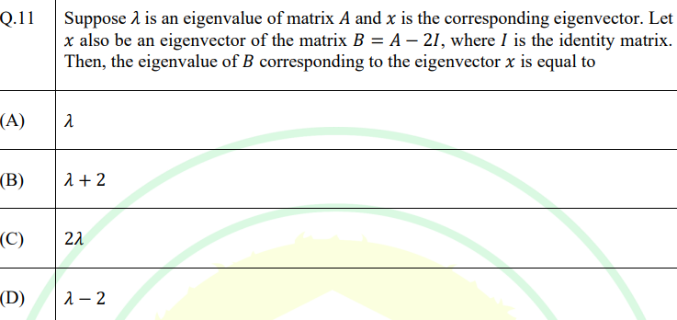

ANS: - D

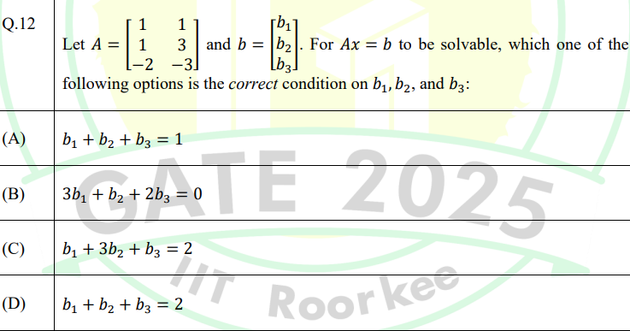

ANS: - B

CE – 2

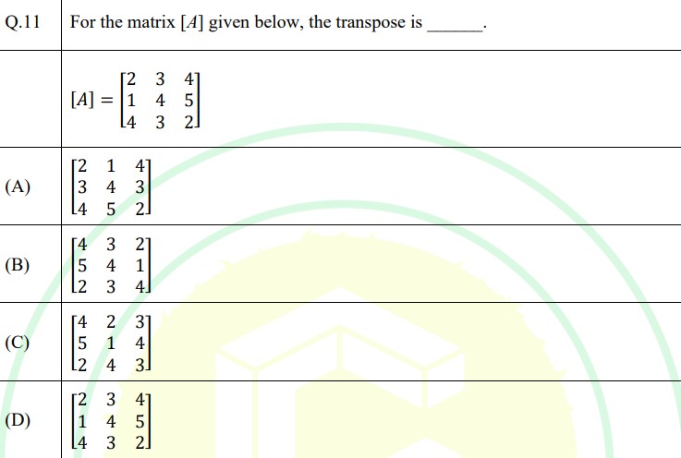

ANS: - A

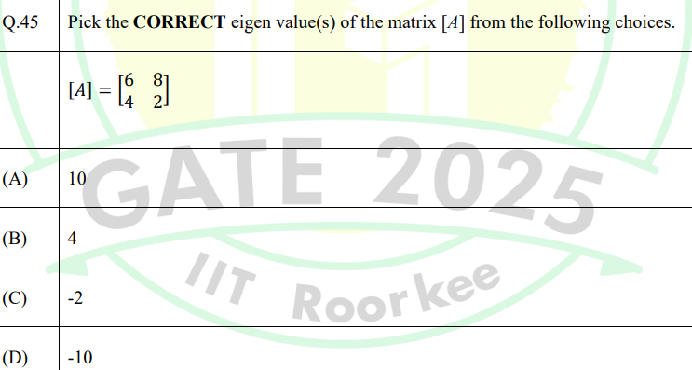

ANS: - A, C

## 2024

**S1**

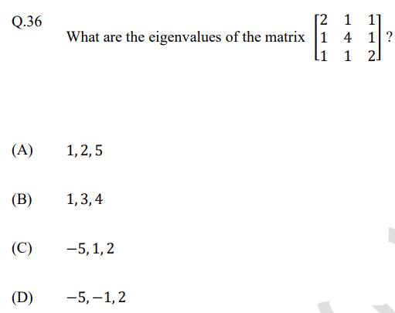

ANS: -

**S2**

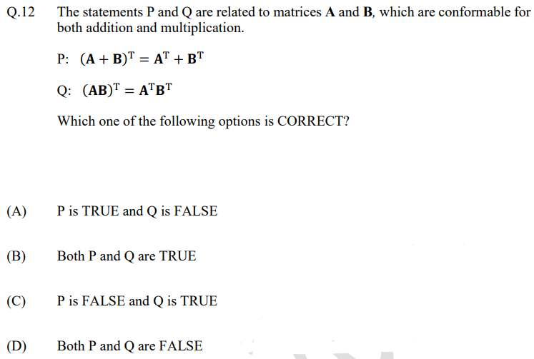

ANS: -

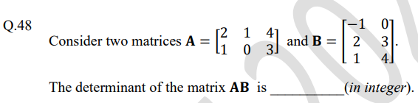

ANS: -

## 2023

**S1**

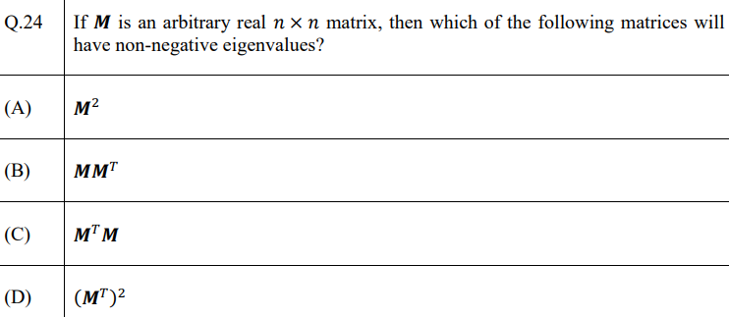

ANS: - B, C

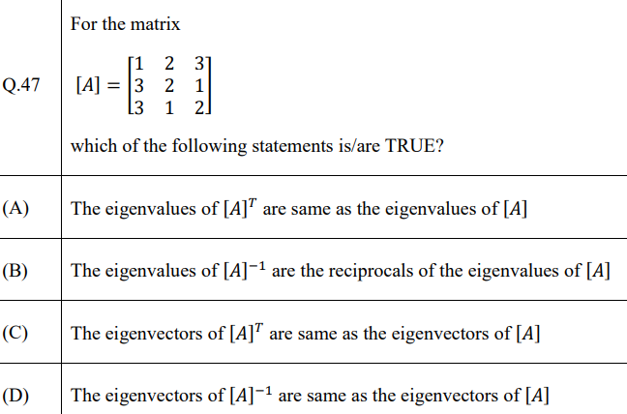

ANS: - A, B, D

**S2**

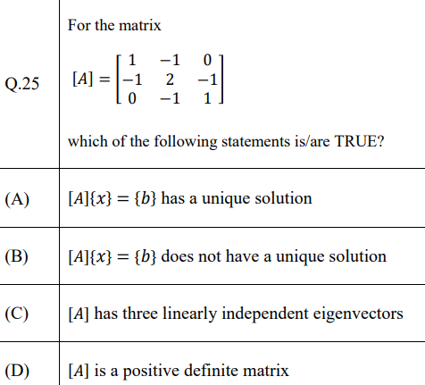

ANS: - B,C

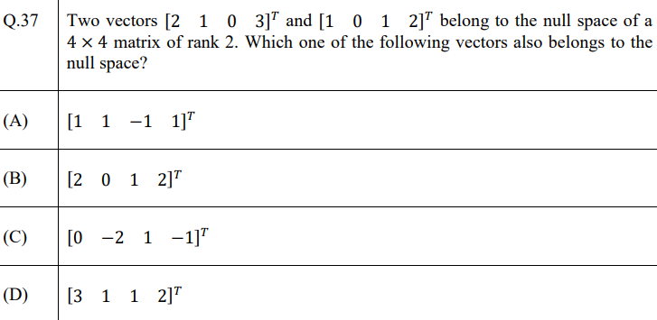

ANS: - A

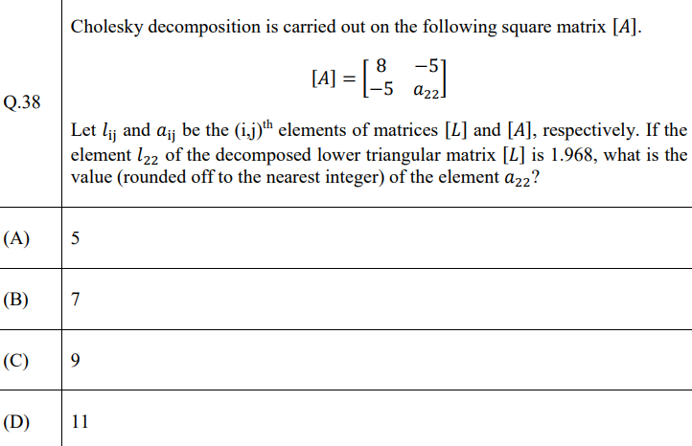

ANS: - B

## 2022

S1

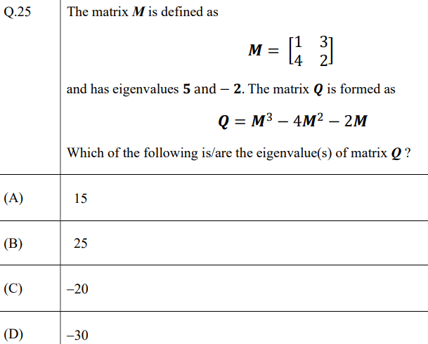

ANS: - A, C

S2

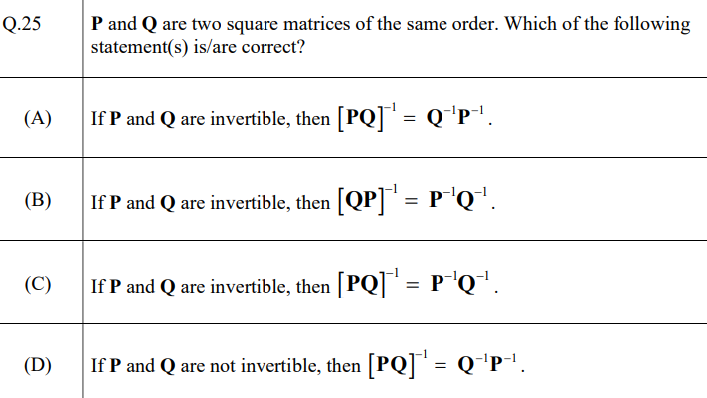

ANS: - A, B

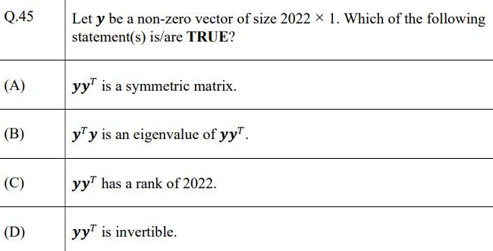

ANS: - A, B

## 2021

S1

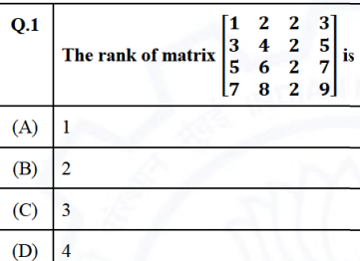

ANS: - B

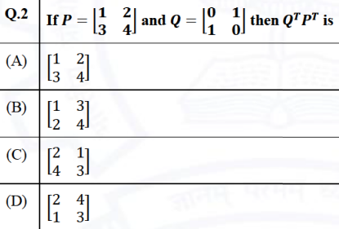

ANS: - D

S2

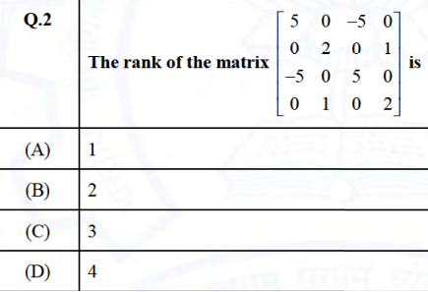

ANS: - C

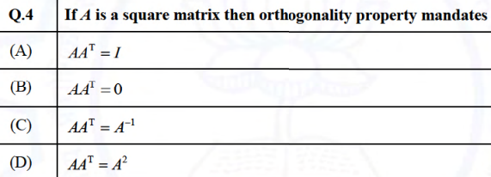

ANS: - A

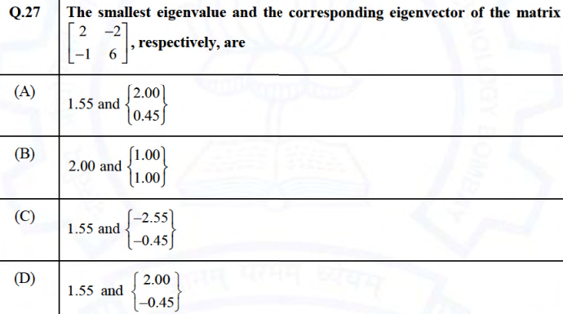

ANS: - A

## 2020

S1

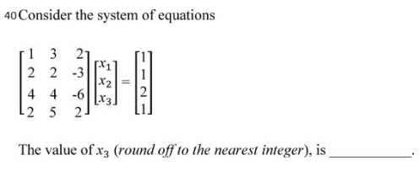

ANS: - 3

S2

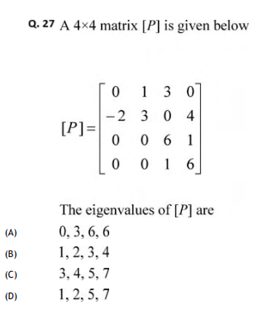

ANS: -

## 2019

S2

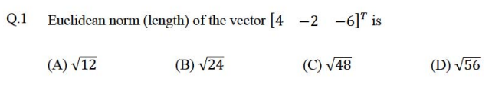

ANS: - D

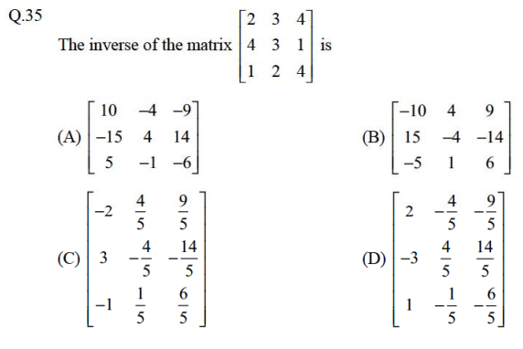

ANS: - C

## 2018

S1

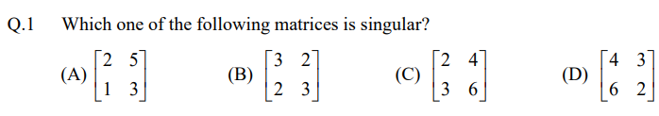

ANS: - C

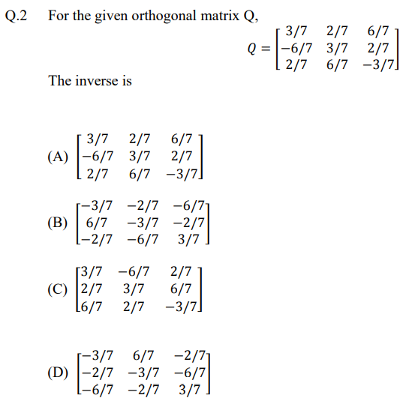

ANS: - C

S2

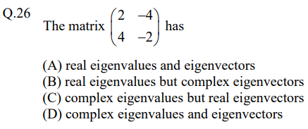

ANS: - D

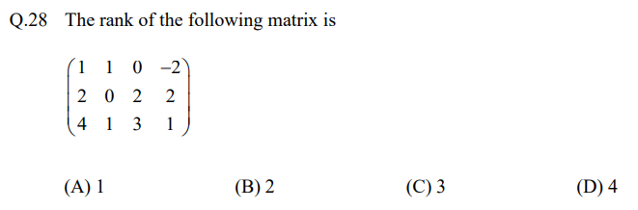

ANS: - B

# **Mechanical**

## 2025

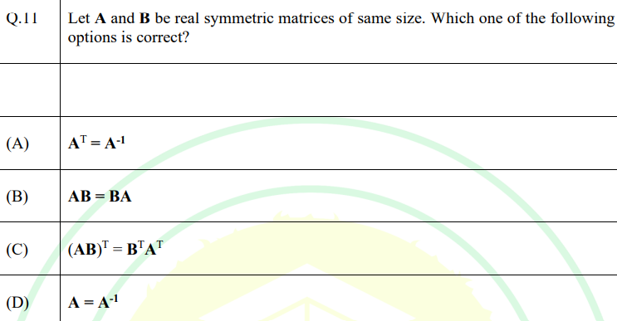

ANS: - C

## 2024

Q.14 Consider the system of linear equations

$$x + 2y + z = 5$$

$$2x + ay + 4z = 12$$

$$2x + 4y + 6z = b$$

The values of 𝑎 and 𝑏 such that there exists a non-trivial null space and the system admits infinite solutions are

(A) 𝑎 = 8, 𝑏 = 14

(B) 𝑎 = 4, 𝑏 = 12

(C) 𝑎 = 8, 𝑏 = 12

(D) 𝑎 = 4, 𝑏 = 14

Q.36 The matrix $\left[\begin{matrix}1 & a \\ 8 & 3\end{matrix}\right]$ (where 𝑎 > 0) has a negative eigenvalue if 𝑎 is greater than

(A) $\frac{3}{8}$ (C) $\frac{1}{4}$

(B) $\frac{1}{8}$ (D) $\frac{1}{5}$

ANS: -

## 2022

**SET – 1**

Q.15 If $A= \left[\begin{matrix}10 & 2k+5 \\ 3k-3 & k+5\end{matrix}\right]$ is a symmetric matrix, the value of k is ____________________ .

(A) **8**

(B) **5**

(C) **−0.4**

(D) $\frac{1+ \sqrt{1561}}{12}$

ANS: -

Q.46 The system of linear equations in real (𝑥, 𝑦) given by

$$\left(\begin{matrix}x & y\end{matrix}\right)\left[\begin{matrix}2 & 5-2a \\ a & 1\end{matrix} \right]= \left(\begin{matrix}0 & 0\end{matrix}\right)$$

involves a real parameter 𝛼 and has infinitely many non-trivial solutions for special value(s) of 𝛼. Which one or more among the following options is/are non-trivial solution(s) of (𝑥, 𝑦) for such special value(s) of 𝛼?

(A) 𝑥 = 2, 𝑦 = −2

(B) 𝑥 = −1, 𝑦 = 4

(C) 𝑥 = 1, 𝑦 = 1

(D) 𝑥 = 4, 𝑦 = −2

**SET – 2**

Q.46 A is a 3×5 real matrix of rank 2. For the set of homogeneous equations **Ax = 0**, where **0** is a zero vector and **x** is a vector of unknown variables, which of the following is/are true?

(A) The given set of equations will have a unique solution.

(B) The given set of equations will be satisfied by a zero vector of appropriate size.

(C) The given set of equations will have infinitely many solutions.

(D) The given set of equations will have many but a finite number of solutions.

Q.48 If the sum and product of eigenvalues of a 2 × 2 real matrix $\left[\begin{matrix}3 & p \\ p & q\end{matrix}\right]$ are 4 and −1 respectively, then |𝑝| is ______ (in integer).

ANS: -

## 2021

SET – 2

Q.1 Consider an $n ×n$ matrix A and a non-zero n × 1 vector p. Their product Ap = a²p, where a ∈ R and a ∈ {-1, 0, 1}. Based on the given information, the eigen value of A2 is:

**(A) α**

**(B) a2**

**(C)**

**(D) a4**  (D) is the correct answer

## 2020

**SET – 1**

Q. 1 Multiplication of real valued squared matrices of same dimension is

(A) Associative (B) Commutative

(C) always positive definite (D) not always possible to compute

ANS: - A

**SET – 2**

Q. 2 A matrix P is decomposed into its symmetric part S and skew-symmetric part V.

If

$S= \left[\begin{matrix}-4 & 4 & 2 \\ 4 & 3 & 7/2 \\ 2 & 7/2 & 2\end{matrix}\right], and V= \left[\begin{matrix}0 & -2 & 3 \\ 2 & 0 & 7/2 \\ -3 & -7/2 & 0\end{matrix}\right]$

Then Matrix P is:

(A) $\left(\begin{matrix}-4 & 6 & -1 \\ 2 & 3 & 0 \\ 5 & 7 & 2\end{matrix}\right)$ (B) $\left(\begin{matrix}-4 & 2 & 5 \\ 6 & 3 & 7 \\ -1 & 0 & 2\end{matrix}\right)$

(C) $\left(\begin{matrix}4 & -6 & 1 \\ -2 & -3 & 0 \\ -5 & -7 & -2\end{matrix}\right)$ (D) $\left(\begin{matrix}-2 & 9/2 & -1 \\ -1 & 81/4 & 11 \\ -2 & 45/2 & 73/4\end{matrix}\right)$

ANS: - B

Q. 19 Let I be a 100-dimensional identity matrix and E be set of distinct (no value appears more than once in E) real Eigen Values. The number of elements in E ____________ .

ANS: - 1

## 2019

**SET – 1**

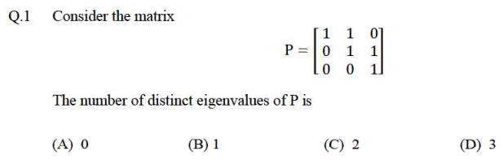

ANS: - B

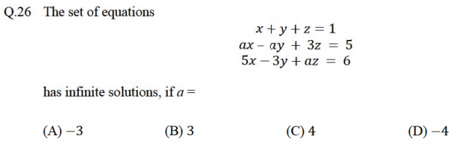

ANS: - C

**SET – 2**

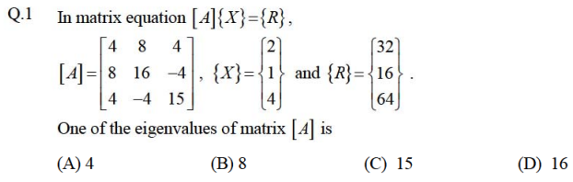

ANS: - C

## 2018

**SET – 1**

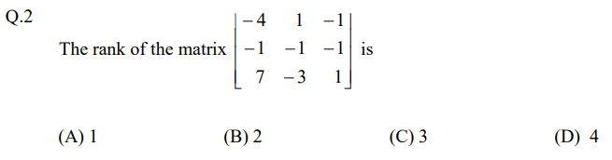

ANS: - B

**SET – 2**

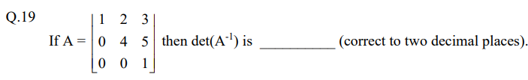

ANS: - 0.25

# **Instrumentation Engineering**

## 2025

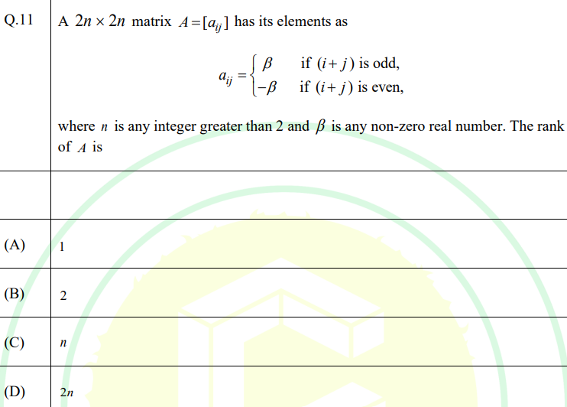

ANS: - A

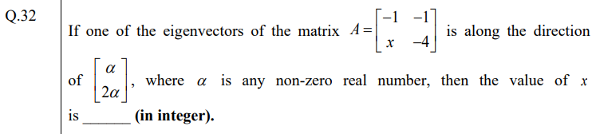

ANS: - 2

## 2024

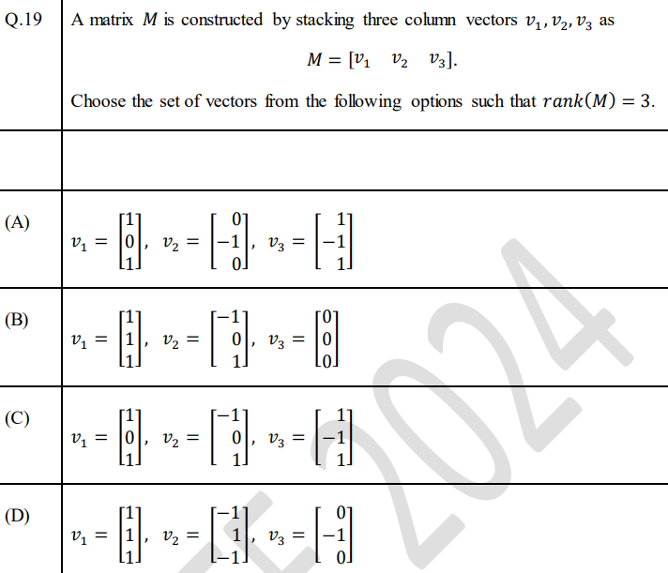

ANS: -

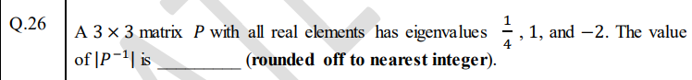

ANS: -

## 2023

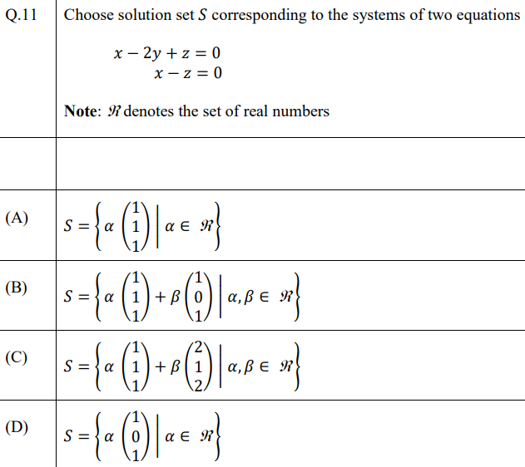

ANS: - A

## 2022

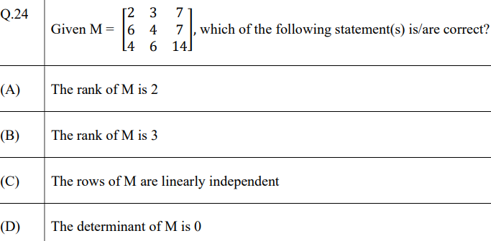

ANS: - A, D

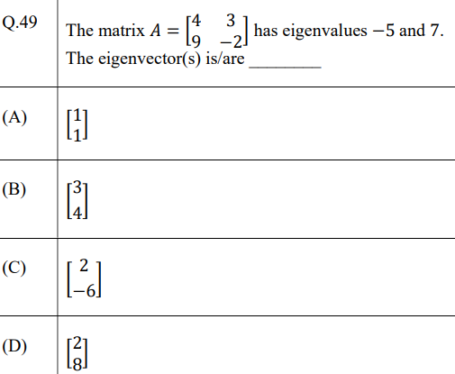

ANS: - A, C

## 2021

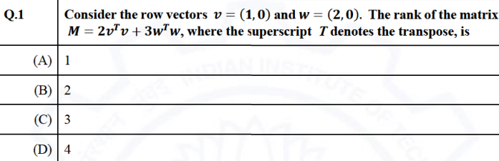

ANS: - A

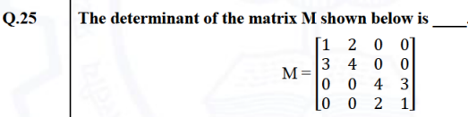

ANS: - 4

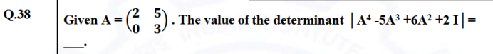

ANS: - 4

## 2020

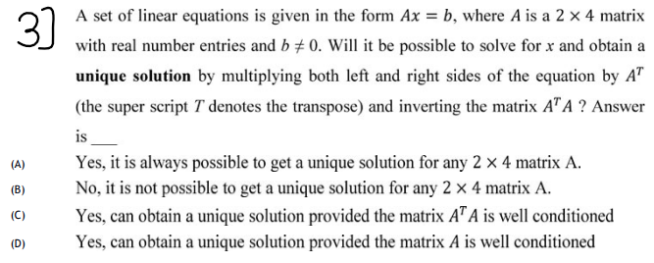

ANS: - B

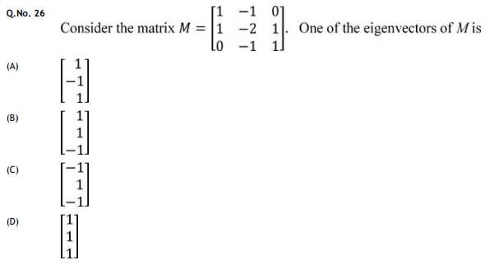

ANS: - D

## 2019



ANS: -

## 2018

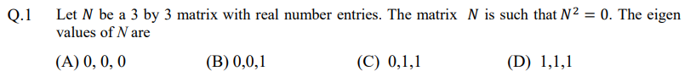

ANS: - A

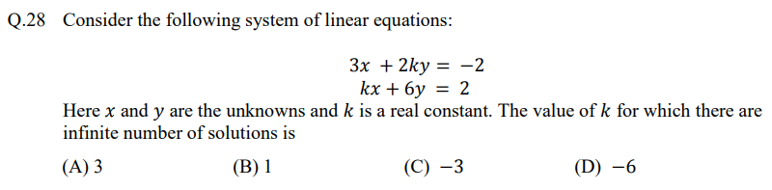

ANS: - C

## 2017

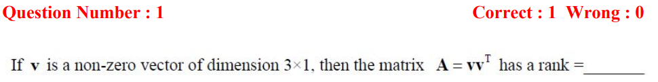

ANS: - 1

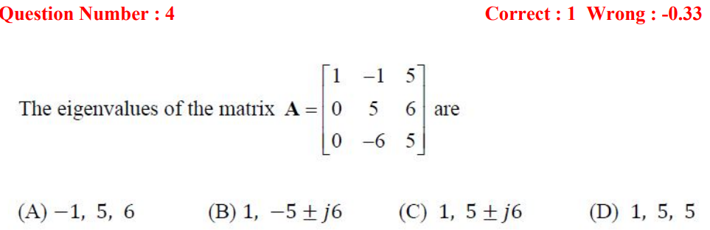

ANS: - C

## 2016

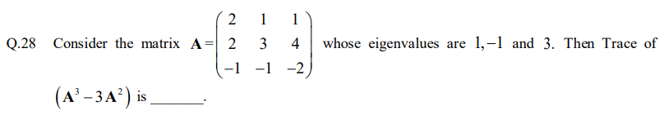

ANS: - (-6)

# **Data Science and Artificial Intelligence**

## 2025

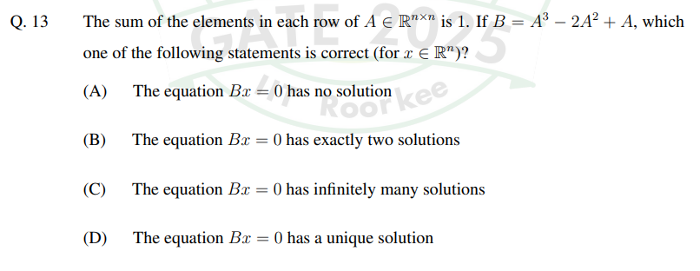

ANS: - C

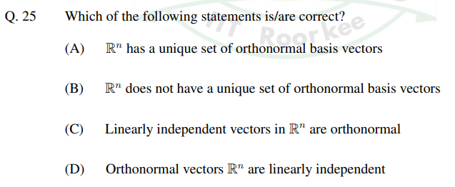

ANS: - B, D

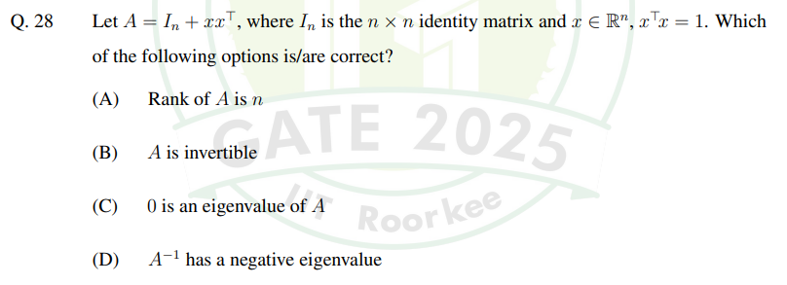

ANS: - A, B

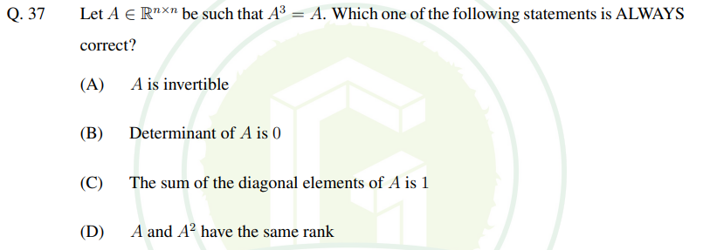

ANS: - D

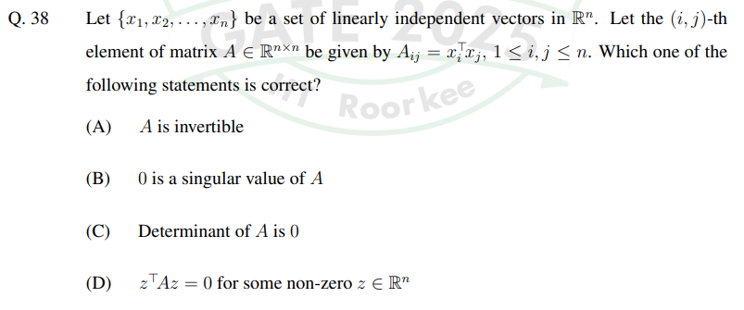

ANS: - A

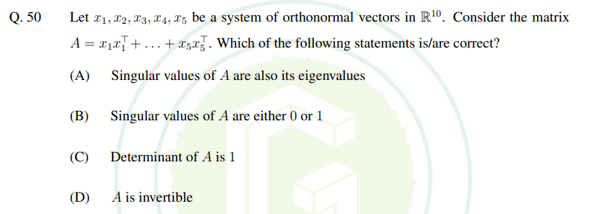

ANS: - A, B

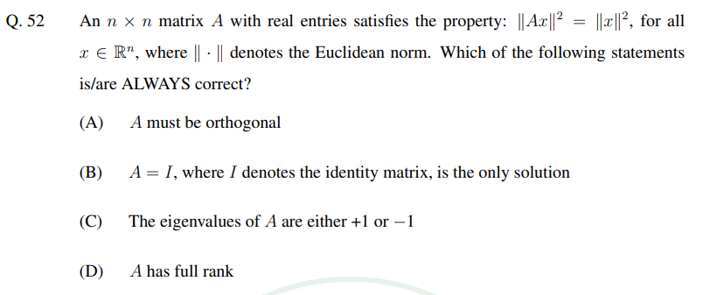

ANS: - A, D

## 2024

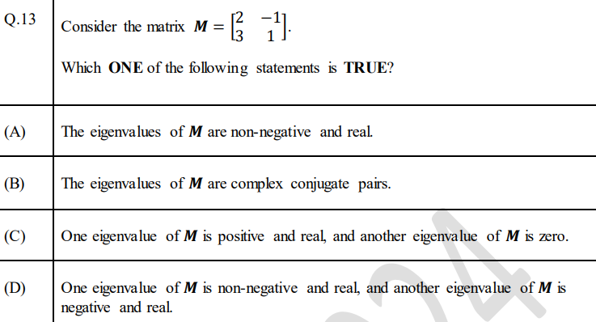

ANS: -

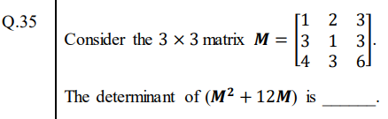

ANS: -

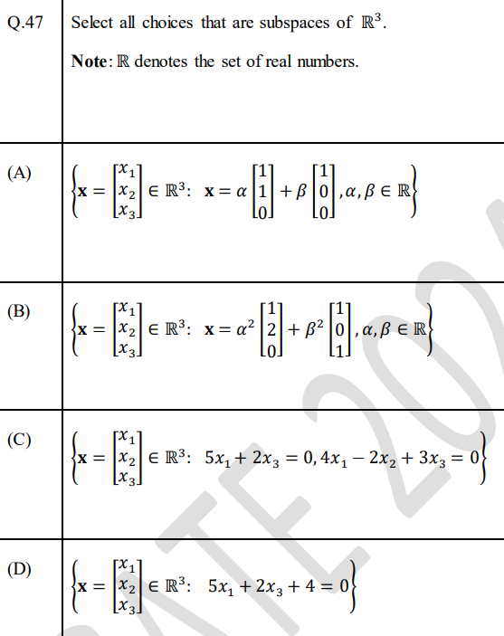

ANS: -

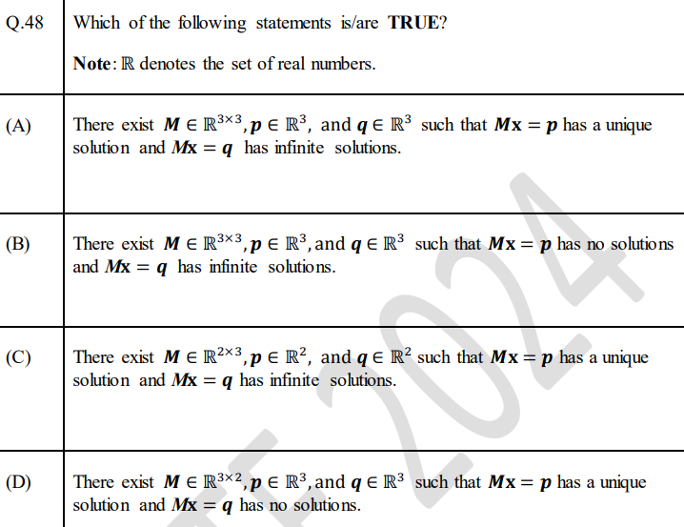

ANS: -

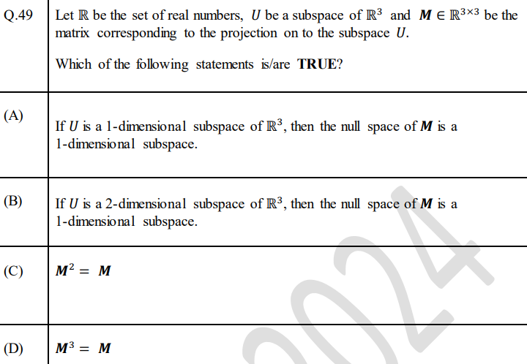

ANS: -

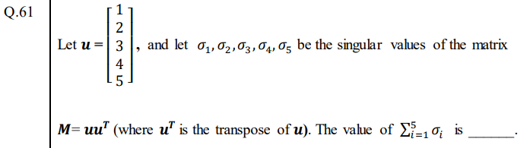

ANS: -

# **IIT JAM – Mathematics**

## 2025

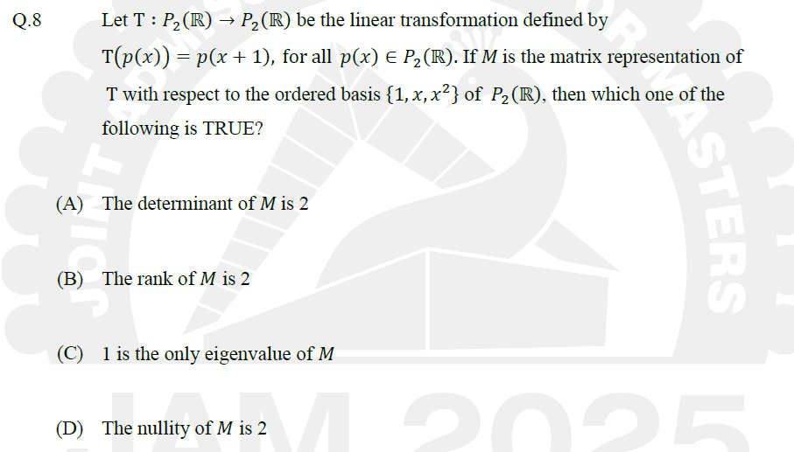

ANS: - C

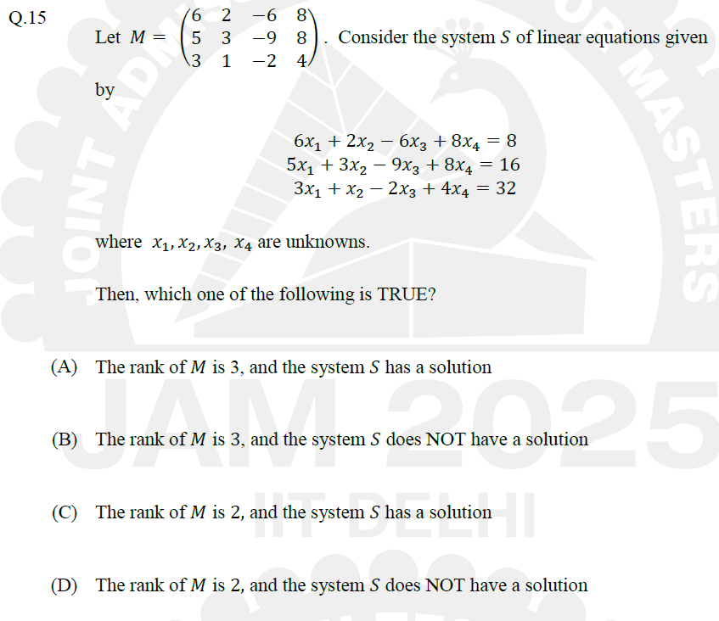

ANS: - A

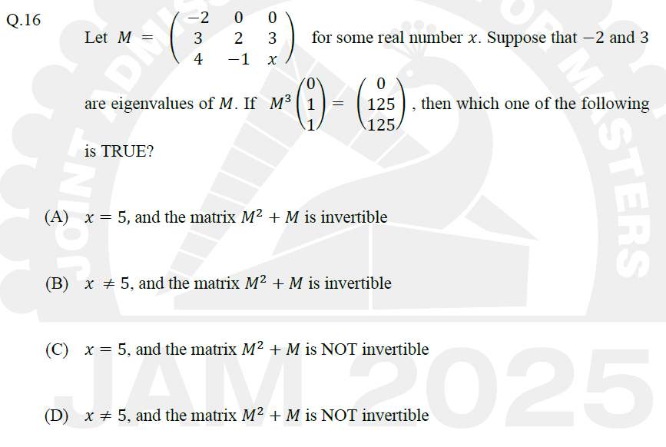

ANS: - B

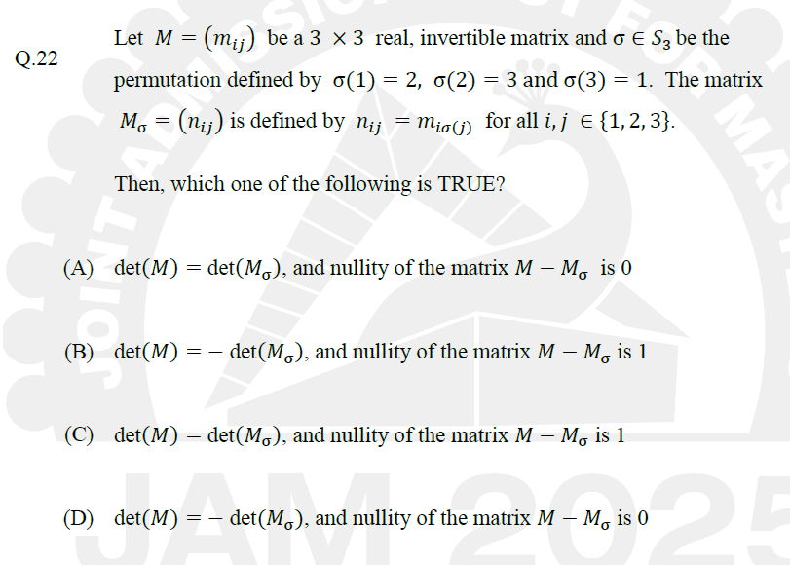

ANS: - C

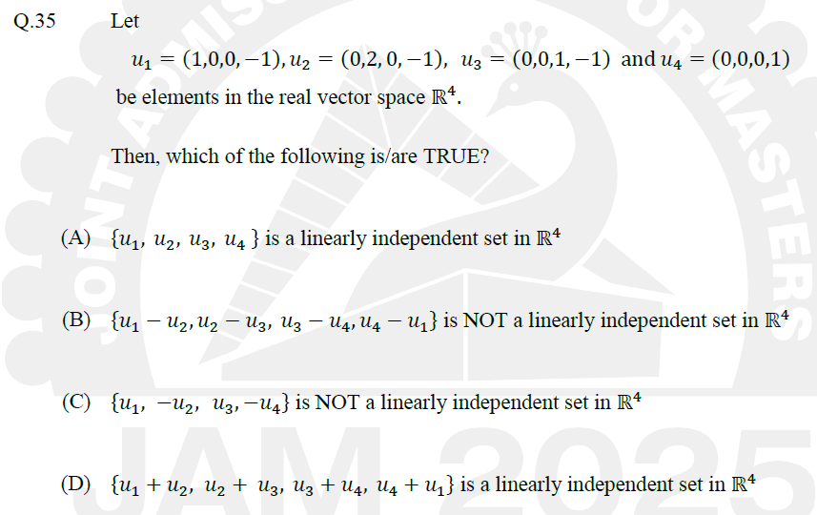

ANS: - A, B

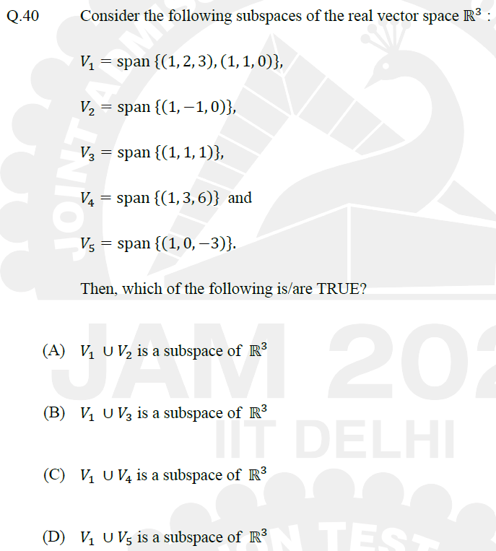

ANS: - C, D

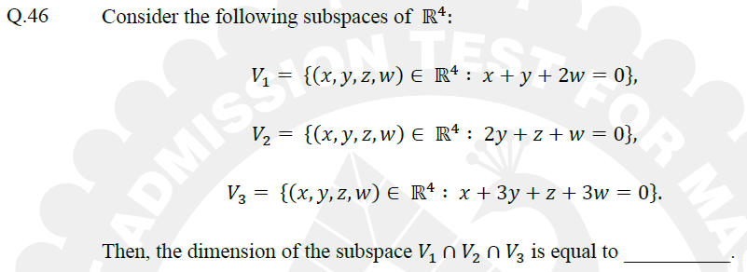

ANS: - 2

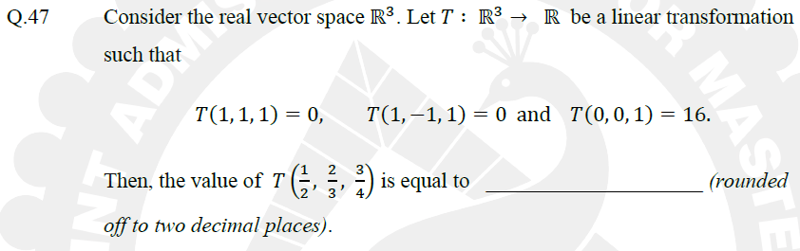

ANS: - 3.98 to 4.02

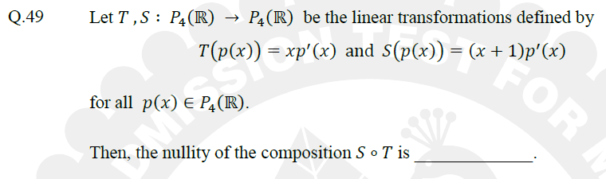

ANS: - 1